Environmental Monitoring Training Material and Comprehension Quiz

- Policy
  - A risk-based approach is in place to define the microbiological environmental monitoring program, which is established, implemented, and maintained to reduce the risk of food contamination.
  - Every element in the environmental monitoring program is addressed to minimize the potential for product recontamination through a documented plan.
  - Ingress or spread of pathogens in the processing facility is prevented.
  - Procedures for verification of pathogens, spoilage, and indicator microorganism controls and corrective actions are established.
  - The facility verifies the effectiveness of the overall hygienic practices and provides the necessary information to prevent possible microbial contamination of food products.
  - The facility identifies potential risks in open product areas that can lead to the production of non-conforming products, consumer complaints, or even an incident.

- Procedure
  - Environmental Monitoring Implementation
    - Create a team (made up of multidisciplinary members with a background in microbiology, food safety, specific production processes of the organization, maintenance/equipment design, etc.).
    - Conduct the risk assessment to build an environmental monitoring program that meets the specific needs of your organization:
      - Define relevant microbiological hazards, including relevant pathogens, spoilage, and/or indicator organisms.
        - Consider the nature of the microorganism, including the ability to survive/grow in certain conditions, including pathogens, spoilage organisms, and indicator organisms.
        - Consider specific hazards that may be relevant to the production environment, including specific hazards of concern linked to the type of product produced.
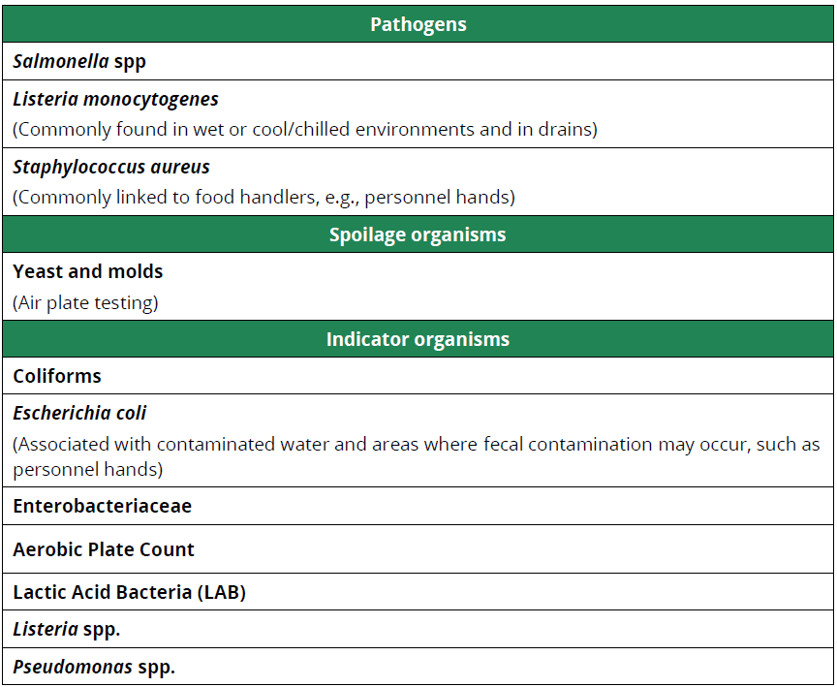
Table 1: Potential Microorganisms of Concern

      - Define environmental monitoring sampling zones of risk related to the different hazards.
      - Define suitable sampling protocols:
        - Sample types: such as swabs, water samples, and air plates. Protein swabs and ATP swabs may also be used for the verification of cleaning.
        - Sampling tools: such as dry or wet cotton swabs, sponge swabs, RODAC plates, and air samplers.
        - Sampling techniques (including which surface size to consider)
        - Sample location/sites: based on the zones listed on the previous page.
        - Test methods: could be rapid or laboratory-based; requirements of FSSC Additional Requirement 2.5.1(a) Management Of Services And Purchased Materials apply.
      - Define appropriate monitoring frequencies for routine sampling.
      - Define when sampling is conducted:
        - Before cleaning (post-production after disassembly and initial rinse, but before application of cleaning chemicals)
        - After cleaning and sanitation
        - Pre-production
        - During production
      - Define appropriate methods for sample collection, storage, and transport, to ensure the integrity of the sample is maintained before analysis.
      - Define action limits, (proposed) corrective actions, and responsibilities in any out-of-specification results detected.
      - Consider additional sampling, over and above routine sampling, in the case of extraordinary circumstances, such as during construction and as a follow-up due to a positive test result.
      - Conduct trending of the results obtained from the environmental monitoring program and implement necessary action to address the results of the trends identified.
    - Annually review the environmental monitoring program once established. Review the environmental monitoring program when consistent negative results are obtained over an extended period of time.
    - Document required procedures and training programs to ensure the principles and role of environmental monitoring are understood across the workforce and any relevant rules are adhered to.
    - Additional considerations when developing the environmental monitoring program:
      - Always adhere to the legal requirements within the environmental monitoring program. Review relevant standards, codes of practice, and guidelines, as well as industry best practices and customer requirements.
      - Determine the risk assessment undertaken by the organization.
  - Zoning Divisions in Environmental Monitoring
    - Zoning
      - Zone 1: Direct contact - areas with direct product/food contact surfaces, where the product is exposed to the plant equipment and environment prior to sealing in the primary packaging. Zone 1 surfaces identified: slicers, peelers, fillers, hoppers, screens, conveyor belts, air blowers, employee hands, knives, racks, and worktables.
      - Zone 2: Indirect contact - non-product contact areas in the plant that are closely adjacent to product contact surfaces. Zone 2 surfaces identified: processing equipment exterior and framework, refrigeration units, equipment control panels, and switches.
      - Zone 3: Close proximity – non-product contact surfaces that are in open post-lethality product-processing areas, but not closely adjacent to Zone 1 surfaces. Zone 3 surfaces have the possibility of leading to product cross-contamination. Zone 3 surfaces identified: forklifts, hand trucks, carts, wheels, air return covers, hoses, walls, floors, and drains.
      - Zone 4: Genera areas - areas remote from post-lethality product-processing areas. Zone 4 areas, if not maintained in good hygienic condition, can lead to cross-contamination of Zones 1, 2 and 3. Zone 3 surfaces identified: locker rooms, cafeterias, entry/access ways, loading bays, finished product storage areas, and maintenance areas.
    - Division
      - Hygienic Zoning-Division of a [ENTER CATEGORY] facility into different areas to avoid food contamination risks. Areas are designated based on risk and can include non-production areas (e.g., offices), basic GMP areas (e.g., raw material storage), and where processed RTE product is exposed to the environment prior to packaging. Hygienic zones should not be confused with environmental monitoring sampling zones, which are used to designate target areas for environmental sampling (i.e., Zones 1 to 4). Also, restrict the movement of hazards from low-risk areas of the factory to medium-risk areas and then to high-risk areas over or near exposed products.
        - Uncontrolled Area – Areas where there are no products (e.g., offices, employee parking area).
        - Low-risk Area – Areas where there are products, but none are exposed to the environment (e.g., raw material and finished product storage area).
        - Medium-risk Area – Areas where products are exposed.
        - High-risk area – Areas where products are sensitive to pathogenic growth and goes to sensitive customers.
        - High-care Zones – Areas over or near exposed products where there is a high probability of contamination.
        - Transition Zones – Areas where barriers and routines exist to prevent the movement of contamination between areas.
  - Environmental Monitoring Program for Pathogens
    - Pathogenic Microorganisms: Description
      - Salmonella spp. – a genus of gram-negative, facultatively anaerobic bacteria of the family Enterobacteriaceae that is often found in the fecal material of birds, livestock, pests, and pets.
      - Listeria monocytogenes – ubiquitous in the natural environment; commonly found in wet or cold/chilled environments and drains.
        - Food Group 1 – ready-to-eat foods that support the growth of L. monocytogenes and have been stored for more than one day (e.g., packaged sandwiches).
        - Food Group 2 – ready-to-eat foods that do not support the growth of L. monocytogenes and have been stored and prepared for more than one day (e.g., salads and dips with low pH).
        - Food Group 3 – ready-to-eat food that will be consumed immediately and has not been stored and prepared for more than one day (e.g., freshly made sushi).
      - Staphylococcus aureus – a gram-positive bacteria commonly linked to food handlers.
    - A defined monitoring of the environment of a [ENTER CATEGORY] facility for pathogenic microorganisms. The goal of EMP is to find and eliminate pathogen contamination in the processing environment They are typically used to (1) verify an overall food safety system (or specific components of a food safety system) and (2) provide an early indication of potential food safety hazards.
  - Environmental Monitoring Program for Spoilage Microorganisms
    - Spoilage Microorganisms: Description
      - Yeast and molds – indicate the presence of fungal spoilage organisms and often used with Total Plate Count (TPC) and Aerobic Plate Count (APC) to verify overall effectiveness of sanitation processes.
    - An environmental monitoring of the [ENTER CATEGORY] facility for determining the verification activity of sanitation which will contribute to microbial quality which increases the risk of spoilage incidents.
  - Environmental Monitoring Program for Indicator Microorganisms
    - Indicator Microorganisms: Description
      - Coliforms – an indicator of overall cleanliness and often used as an indicator of potential presence of pathogenic E. coli.
      - Escherichia coli – associated with contaminated water and areas where fecal contamination may occur, such as personnel hands.
      - Enterobacteriaceae – one of the indicators of overall cleanliness that includes a wide range of microorganisms making them effective indicator tests. often used as an indicator of the potential presence of Salmonella.
      - Aerobic Plate Count – indicates the total microbial population on the test surface, both bacteria and fungi. It serves as an excellent indicator of overall hygiene and the effectiveness of sanitation practices.
        - Category A – ready-to-eat food in which all components are fully cooked for immediate sale or consumption.
        - Category B – ready-to-eat foods that are fully cooked with further handling or processing before consumption.
        - Category C – food that contains uncooked fermented ingredients or fresh fruit and vegetables.
    - An environmental monitoring of the [ENTER CATEGORY] facility for determining the general microbial condition of food or environment. The presence of indicator organisms does not provide any information on the potential presence or absence of a specific pathogen, nor does it provide an assessment of potential public health risk but it will determine the hygienic status of the processing equipment and environment, validation and verification of cleaning and sanitation, and assessment of post-processing contamination.
  - Environmental Sampling
    - Sampling Collection
      - Sampling Materials and PPEs
        - Sterile gloves (sizes 7 and 9 to include latex freestyles)
        - Hand sanitizers (wash and sanitize hands often during sampling)
        - Cooling medium for samples
        - Boxes or coolers
        - Labels to ID samples
        - Permanent marker
        - Flashlight Sterile metal spatulas (small) or other sterile implements to scrape debris out of cracks
        - Approved Swabbing Sponges and Sterile Swabs
        - Hair and beard restraint (disposable)
        - Hearing protection (earplugs or earmuffs)
        - Clean disposable coverall suits
        - Clean disposable booties
        - Sleeve guards
        - Hair cap
        - Face mask
        - Approved footwear
        - Whirl-Pak
        - Sponge-stick
        - Swab
      - Neutralizing broth/buffer (for pre-moistened sponges and/or swabs)
    - Sampling Points
      - Raw materials
      - Environmental monitoring zones
      - Finished products
      - Water system
      - HVAC system
    - Sampling Techniques
      - Preparation of Pre-Moistened Sponges and Swabs
        - Pour sufficient amount of neutralizing broth inside the sponge-stick or swab stick bag. Ensure to not spill any broth on the stick’s handle.
        - Massage the sponge or swab through the outside of the bag.
        - Squeeze the excess neutralizing broth before using and ensure to have a sterile glove on the hand to be used for swabbing. Do not touch any non-sterile surfaces before retrieving the instrument.
      - Swabbing Procedure for Sponges
        - The sample area must be 12” x 12” (one square foot).
        - Wipe the sponge from left to right and cover the entire square.
        - Turn the sponge over and wipe it down, covering the entire square.
      - Swabbing Procedure for Sterile Swabs
        - The sample area must be 4” x 4”, approximately 16 square inches, or 2” x 8”.
        - Swab from left to right, covering the entire square.
        - Swab up and down, covering the entire square.
        - Swab diagonally, covering the square, and rotate the swab tip during the process and use firm pressure.
    - Sampling Labelling
      - Collected samples must be labelled for traceability purposes with details including:
        - Sample/material name.
        - Sampling point or location
        - Microbiological test to be done.
        - Date and time of swabbing.

- Responsibility
  - QA Manager
    - Develop and implement procedures and protocols for EMP activities.
  - QA Supervisor
    - Oversee the environmental monitoring program.
    - Provide training and guidance on proper sampling techniques, equipment operations, and data recording procedures.
  - Sanitation Manager
    - Conduct a regular sanitary inspection.
  - Maintenance Manager
    - Maintain all equipment used for environmental monitoring.
    - Conduct regular equipment inspection.
  - Production Manager
    - Oversee the implementation of EM procedures within the production area.
  - Laboratory Technician/Microbiologist
    - Perform sampling of surfaces, air, water, and other relevant sampling points.
    - Conduct analyses to identify the microbiological results of sampling points.

- Corrective Action
  - If pathogens are detected in each zone:
    - Zone 1
      - The affected line of production must be immediately stopped.
      - Conduct an in-depth examination of the affected area and inspection.
      - Extensive cleaning is done on the affected site within a 50-foot radius and Zone 2 and 3 adjacent areas and swab sites.
    - Zone 2
      - Production lines must be broken down for inspection.
      - Restrict traffic flow in the affected areas to the extent possible.
      - An in-depth area examination is done (Visually and Vector Swabbing).
      - Swabs are collected from Zone 2 and 3 after extensive cleaning in a 50-foot radius. The sampling frequency is increased until three consecutive negative results are achieved.
      - In the event of 2 persistent positive Zone 2, Zone 1 swabbing or the finished product testing is initiated.
    - Zone 3
      - Restrict traffic flow in the affected areas to the extent possible.
      - An in-depth area examination is done.
      - Swabs must be collected from Zone 3 after extensive cleaning in a 50-foot radius.
  - Sampling frequency must be increased until three negative results are achieved.
  - Train all personnel on environmental monitoring verification and corrective actions
  - Require re-training and evaluation for non-compliant personnel.

- Review – Quality
  - Control procedures for environmental monitoring shall be reviewed as part of the initial desk audit.
  - Control procedures are effectively implemented for product processes.
  - Process and materials flow and product transfer points do not create a potential for contamination.
  - Post-process areas are not at risk from pedestrian walkways.
  - High-risk areas are adequately segregated from raw material handling areas.
  - High-risk areas are only serviced by staff dedicated to that function.
  - Personnel performing environmental sampling followed proper hand-washing and sanitation, using sterile PPEs pre-procedure.
  - EMP Review
    - The environmental monitoring program is reviewed and assessed on an annual basis by the EMP Team – utilize assessment form.
    - Data trending analysis must be used to interpret and validate environmental monitoring program effectiveness.

- History
Revision No.: | Revision Date: | Description of Change: | Originator / Author Name: | Title / Department:
0 | YYYYMMDD | Original | ENTER AUTHOR NAME | ENTER TITLE/ ENTER DEPARTMENT

Requirements:
- The trainee (employee/visitor) has read or received a verbal translation of all or part of the policy, procedure, method, and/or SOP for which they are being trained.
- The trainee has observed a demonstration of the task they are to perform or the procedure for which they are being trained as required.
- The trainee has demonstrated the ability to perform the task with acceptable proficiency and minimal supervision.

TRAINEE (Print Name): | TRAINEE (Signature): | Date: | Department:
Trainer / Supervisor (Print Name): | Trainer (Signature): | Date: | Department:

*Should you need assistance in customizing this document please email shop@consultareinc.com

NAME (Print): | Date:

Environmental Monitoring Comprehension Quiz

Direction: Choose the best answer and encircle the letter.

1. What relevant microbiological hazards need to be defined in building an environmental monitoring program?
- Yeast and molds
- Pathogens, spoilage, and/or indicator organisms
- Listeria monocytogenes

2. When will the environmental monitoring program be reviewed once established?
- Monthly
- Bi-annually
- Annually

3. Should procedures and training programs be documented to ensure the principles and role of environmental monitoring are understood across the workforce?
- True
- False

4. Conduct _______ of the results obtained from the environmental monitoring program and implement necessary action to address the results of the trends identified.
- trending
- inspection
- training

5. Responsible for conducting analyses to identify the microbiological results of sampling points.
- QA Manager
- Laboratory Technician/Microbiologist
- None of the above

*Should you need assistance in customizing this document please email shop@consultareinc.com

Comprehension Quiz: ANSWER KEY

1. What relevant microbiological hazards need to be defined in building an environmental monitoring program?
- Yeast and molds
- Pathogens, spoilage, and/or indicator organisms
- Listeria monocytogenes

2. When will the environmental monitoring program be reviewed once established?
- Monthly
- Bi-annually
- Annually

3. Should procedures and training programs be documented to ensure the principles and role of environmental monitoring are understood across the workforce?
- True
- False

4. Conduct _______ of the results obtained from the environmental monitoring program and implement necessary action to address the results of the trends identified.
- trending
- inspection
- training

5. Responsible for conducting analyses to identify the microbiological results of sampling points.
- QA Manager
- Laboratory Technician/Microbiologist
- None of the above

